Palestine Red Crescent Society
Gaza Situation Updates
This report covers the period of 03/01/2009 (09:00am) till 04/01/2009 (09:00am)

For the ninth consecutive day of the Israeli military operation in the Gaza Strip, PRCS is still at its highest level of alert in the occupied Palestinian territory (oPt). PRCS remains extremely concerned over the large number of civilians wounded and killed as a result of the heavy Israeli air strikes and indiscriminate bombardments all over the Gaza strip, and the shortage of medical supplies and relief items.

Since the beginning of the Israeli military operations, a total number of 462 Palestinians, including 75 children and 26 women, have been killed, and at least 2338 others were wounded, including more than 200 wounded in a critical condition. According to Palestinian medical records, at least 670 children and 320 women have been injured since the beginning of the military operation.

During the past 24 hours, an escalation in the military operation has occurred mainly after the launching of the ground offensive last night. The PRCS ambulances and medical teams were dispatched to at least 57 locations, where Israeli army conducted air strikes, land and see bombardments. According to PRCS records, at least, 32 Palestinian civilians were killed, including children, and approximately 132 others were injuries.

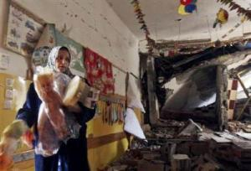 | 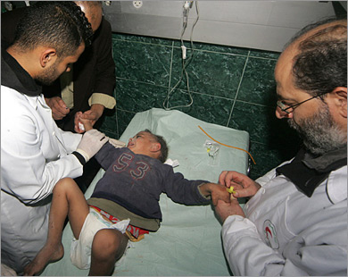

Situation in Gaza hospitals:

Gaza Strip hospitals and medical premises have suffered severe shortages of medical supplies over the past 18 months' blockade and are not equipped enough to receive mass casualties. Hospital Operating Rooms are overflowing, and running out of essential medicines. Hospitals and other medical facilities are also understaffed and not able to respond to the load of injuries. Hospitals were being overwhelmed with patients and were running out of space and supplies.

Gaza Strip is densely populated. Its 1.5 million residents are already facing shortages in medicine and basic relief supplies due to 18-month Israeli blockade. Current prognosis is for the crisis to continue with increased casualties.

Palestine Red Crescent Intervention:

The Palestine Red Crescent Society (PRCS) is responsible for the provision of relief and humanitarian services; Ambulance services (EMS), Disaster response, Primary health care and Hospital care.

Since the beginning of the Israeli offensive, around 200 PRCS volunteers, 60 medics and 120 medical staff were actively involved in providing emergency care in Gaza Strip.

According to the PRCS EMS stations records, approximately 900 persons including 236 fatalities were transported by the PRCS ambulances since the beginning of the military operation.

PRCS dispatched three ICU ambulances at the Rafah border to assist the ministry of health in transporting the wounded cases to Egypt and other Arab countries.

Today, PRCS blood transfusion services are attempting to send 260 units of blood to Gaza Strip through the ICRC. Other units will be sent later on after testing.

PRCS' challenges:

PRCS evacuated some of its premises for safety reasons. Today PRCS EMS station in Jabaliya was evacuated for safety reasons. PRCS EMS station in Gaza faces the cut of telephone network, affecting the respond of the 101 to people's calls. An alternative line was organized, and the PRCS calls upon the people in Gaza city to contact the PRCS operations room in Gaza and PRCS Al Quds hospital if there is any emergency, and the telephone numbers were published in the local media agencies. Moreover, the Israeli Army attacked the civil defence station north of Gaza and penetrated the PRCS VHF communication line. As a result it was suspended for several seconds.

Other issues:

PRCS President, Mr. Younis Al Khatib, travelled to Egypt and attended the meeting of the General Secretariat of the Arab Red Crescent and Red Cross organization, which stared today and will discuss the coordination of entering the humanitarian assistance to Gaza Strip and the transporting of Palestinian wounded from Gaza Strip to Egypt and other Arab countries, through the cooperation of the Egyptian Red Crescent society. I addition, Mr. Al Khatib and other Red crescent and Red cross societies' presidents and officials visited yesterday Al Areesh airport and Rafah border, to oversee the different issues of humanitarian assistance there.

Urgent needs:

Medical Disposables and surgical kits
Medical First Aid Kits
Inter Agency Health Kits (WHO)
Hygiene and cleaning kits

Donate to alleviate the humanitarian suffering in Gaza:

PRCS launched Gaza emergency appeal 2009 that could be access through PRCS website www.palestinercs.og

Direct donations could be done through Palestine red crescent special account number 9090- 652753/513 - Arab Bank - Ramallah Al Balad Branch, Swift No. ARABPS 22090 - Correspondent Bank: CREDIT SUISSE
(HEAD OFFICE) - ZURICH CH - SWIFT CODE: CRESCHZZ80A
OUR USD ACC. # 0835080431314780

THROUGH: AMERICAN EXPRESS
SWIFT CODE: AEIBUS33 - ROUTING # 026001591

Or

Donate online through special account at Map Canada

You can donate on line by clicking on the link http://www.mapcan.org/english.html and click on ‘’donations’’, then select the button donate now of ‘’Canadahelps’’ 

Select ‘’Medical aid for Palestine’’, then ‘’ Emergency Campaign for Gaza’’for the fund designation and finally write for PRCS in the note section..

